Surrender to the darkness and follow your instincts…
“What an amazing start to a new series. I couldn’t put Primal Captive down. The shifters in the Prowler series are sizzling hot and not what I expected. A very fresh twist to shifter romance. I’m looking forward to more in this unique series!”
Book Info:
Killers aren’t the only monsters to lurk in the darkness.
Jaxx Savage finds the human that unknowingly saved him from hunters, left for dead in an alley. Making a life or death decision, Jaxx breaks all the rules and performs an unsanctioned change. It doesn’t take Jaxx long to discover he wasn’t the only predator prowling in the shadows.
Since being thrust into a world of darkness and danger, Lucas Bishop’s life has spun out of control. Taming the beast now a part of him, he is glad to get back to his wife and daughter. Only, an unknown enemy has other plans.
In this novella decisions will be forced, lives will be changed and when the truth is revealed, it’ll be too late.

Teasers:
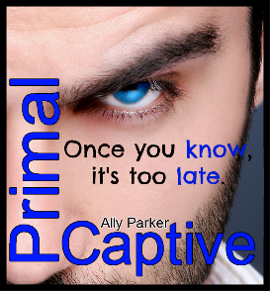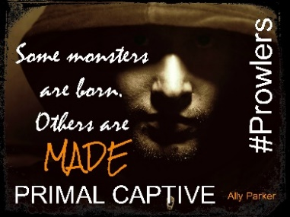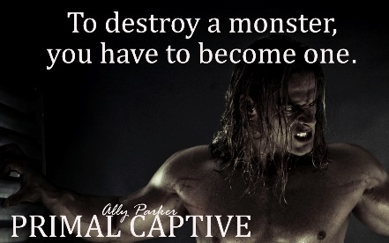
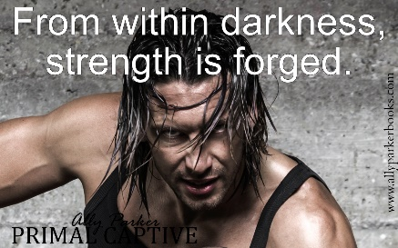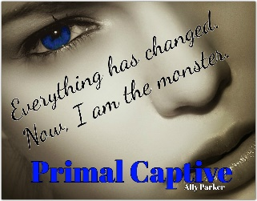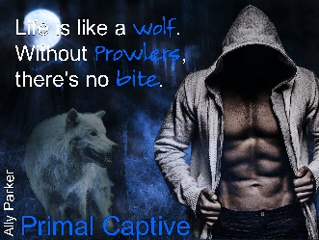

Insert Book Trailer Link:

https://youtu.be/4GY025L4eW8

Get your copy today:
Amazon US:
Amazon UK:
Amazon CA:
Amazon AU:

About the author:
Debuting Ally Parker is a fresh independent author who writes paranormal romance filled with suspense that will keep you turning the page until the very end. Ally recently won a Writing Contest for Primal Instincts her debuting novel in her shifter series, Prowlers.
Besides her writing, Ally is a nurse by day and a mother twenty for seven. If she’s not working on her next book, you’ll find her practicing archery (just in case there is a zombie apocalypse), chasing her kids or storms to capture amazing lightening shots. In her down time, she normally is reading a vampire of shifter book, hanging out with her family or feeding her social media addiction.

Social Media Links
*Author FB page: www.facebook.com/AuthorAllyParker/
*Website: www.allyparkerbooks.com
*Newsletter: https://goo.gl/forms/aMyWZIf6mx6866Pr1
*Pinterest: www.pinterest.com/allyparkerbooks/
*Twitter: www.twitter.com/AllyParker01
*Goodreads:
*Instagram: www.instagram.com/ally_parker_author/?hl=en

